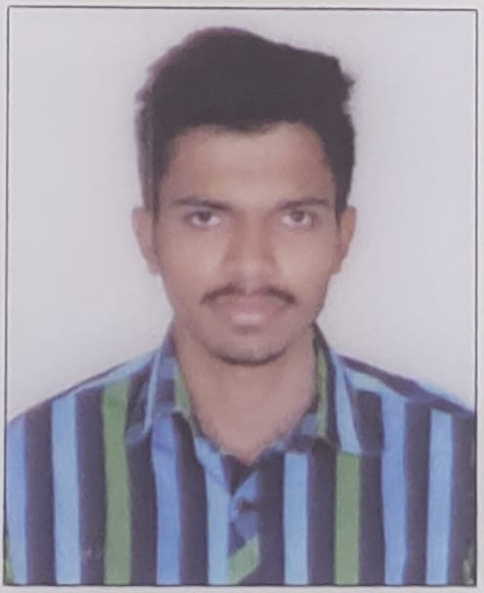 |  |  |  | BODA SAMUEL VARA PRASAD

Experience
- Fresher

Education
Sai Siddhartha High School, Hyderabad, Telangana
- Completed schooling in 2019 with 8.3 GPA
Sri Gayatri Junior College, Hyderabad, Telangana
- Completed intermediate in 2021 with 8.8 GPA
ACE Engineering College, Hyderabad, Telangana
- Pursuing since 2021
- Current CGPA: 8.32

Communication
- Good at written and verbal communication skills.
- Empathic listener and persuasive speaker.
- Writing creative or factual.
- Good at presentation and negotiation skills.

Certifications
- I have received internship certificate from Mentorship program on data structure from ORBO in association with Teechnook.
- I have been certificated by salesforce department virtual internship for completeing the internship successfully.
- Certificate in web designing contest conducted in our college
- I have received participation certificate from Jawaharlal Nehru Technology University Hyderabad for reaching the Grand finale of University level short film competition on 'narcotic drugs'
- Im certificated by Cambridge English entry level in ESOL international for clearing the Cambridge assessment.
- I have received a participation certificate from my college for participating in web designing contest.
- I have received 1st prize certificate from my college in the short film competition conducted by my department.

Soft Skills
- Communication
- Problem solving
- Leadership
- Project management

Technical Skills
- Problem Solving through C
- JAVA
- C++
- Data Structures
- Python
• HTML, CSS, JAVA SCRIPT

Strengths
- Im a Fast learner.
- Determined towards the work I'm committed to.
- can do best even under pressure.

Weakness
- I'm a perfectionist. I Expect perfection in the things that I work on.
- I'm too punctual. which puts me in a constant hustle.

Hobbies
- Playing Cricket
- Exploring New Things
- Exercising
- Photography

Interested Domains
- Software Developer
- Data Scientist
- Web Developer
- Application Developer
- Generative AI

 |  | 9-531/6 , shivanandapuri colony , Rampalli X road , Hyderabad , Telangana -500083
 |  | 9381554562,7569786475
 |  | rajsamuel995@gmail.com

